**SOLVED QUESTIONS**

1. a) The MOSFET-based Switch Mode Power Supply (SMPS) circuit shown in Figure 1 is activated using an astable multivibrator. Build a 555-timer-based astable multivibrator to control the output voltage with the following circuit parameters in Multisim simulator software. Hence, record the values of load voltage and inductor current.

Input voltage = 12V C2 = 100nF Q1 = IRF540

L1 = 10mH D1 = 1N4007 C1 = 1.5uF

Timing capacitor = 1uF R1 = 1kΩ

[Take: R1 = 1kΩ, R2 = 1kΩ for vibrator components] **[6 Marks]**

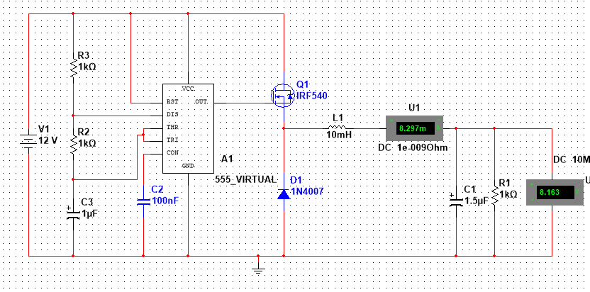

**Solution:**

Load voltage = 8.163V

Inductor current = 8.297mA.

c) A load ZL = 100 + j50 Ω is connected across a TL with Zo = 50 Ω and l = 0.4λ. At the generator end, d = l, the line is shunted by an impedance Zs = 100 Ω. What are the input impedance Zin and admittance Yin of the line, including the shunt connected element. **[6 marks]**

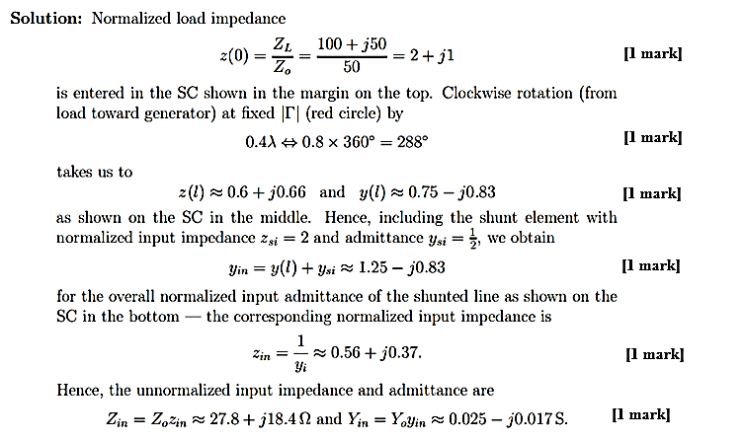**SOLUTION:**

2. a)

(iii) Insert the iron metal rod into the output coil of the inductive heater. Ensure that the rod is positioned centrally within the coil for uniform heating. Activate the power supply and allow the system to run for a duration of 10 seconds. Hence, describe the theory behind this experiment.

(iv) During this period, observe and comment on any changes in the iron rod. Carefully remove the iron rod from the output coil. Using the thermometer supplied to you by the technician measure and record the surface temperature of the iron rod.

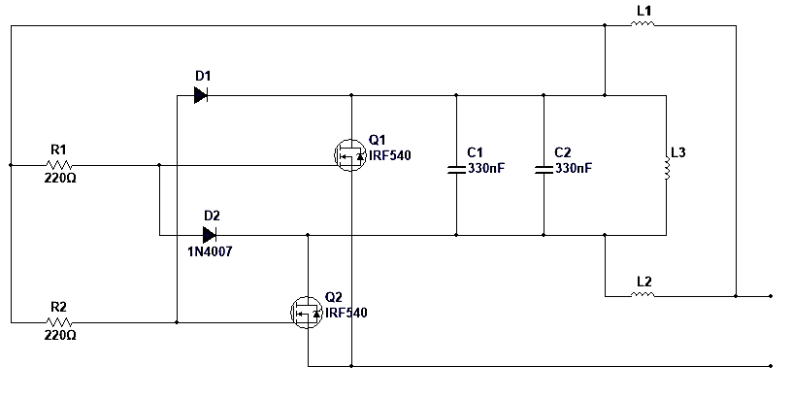

**Figure 3**

**SOLUTION:**

iii) The theory behind the experiment is inductive heating. Inductive heating works by generating eddy currents within the metal rod due to the alternating magnetic field produced by the inductors. These eddy currents cause resistive heating, thereby raising the temperature of the metal rod.

iv) After measuring the temperature of the iron rod, the temperature will lie between 45 to 130 degrees within the 10 minutes period.

b) Figure 4 shows a relay protective circuit design using an Arduino microcontroller and a 5V relay. Write a C programming code in the Arduino environment to protect the circuit against 1A.

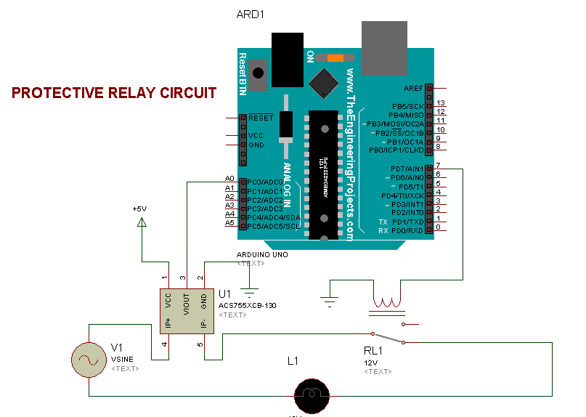

\

**Figure 4**

**SOLUTION:**

b)

const int sensorIn = A0;

int mVperAmp = 185;

double Voltage = 0;

double VRMS = 0;

double AmpsRMS = 0;

int relaypin=7; [2 marks]

void setup(){

pinMode(sensorIn,INPUT);

pinMode(int relaypin,OUTPUT); [1 marks]

}

void loop(){

Voltage = getVPP();

VRMS = (Voltage/2.0) *0.707;

AmpsRMS = (VRMS * 1000)/mVperAmp;

if (AmpsRMS<=0.1)

{

AmpsRMS=0.00; [1 marks]

}

else{

AmpsRMS=AmpsRMS;

}

delay(500);

if (AmpsRMS>=1.0)

{

digitalWrite(relaypin,HIGH); [1 marks]

delay(2000);

}

else{

digitalWrite(relaypin,HIGH);

delay(2000); [1 marks]

}

3. a) How can you test the insulation integrity of a high-voltage circuit breaker in a laboratory setting? [use the following headings as a guide: Preparation, Testing procedure, interpretation]

Do it yourself

Figure 8

b) i) The circuit shown in Figure 8 aims to implement PZEM sensor to measure a.c waveform quantities of an apartment. Replicate the circuit using the hardware components provided by the laboratory technician.

**[4 marks]**

iii) Load the C program code shown below unto the microcontroller, hence power the circuit and record the values of the following quantities with respect to the different loads connected as shown in table 1. **[NB: energy is recorded after 3 minutes]**

**[6 marks]**

#include <PZEM004T.h>

PZEM004T pzem(10, 11); // Create PZEM object with Software Serial pins

void setup() {

Serial.begin(9600);

}

void loop() {

float voltage, current, power, energy, frequency, powerFactor;

if (pzem.readVoltageCurrent(voltage, current, power, energy, frequency, powerFactor)) {

Serial.print("Voltage: ");

Serial.print(voltage);

Serial.print("V, Current: ");

Serial.print(current);

Serial.print("A, Power: ");

Serial.print(power);

Serial.print("W, Energy: ");

Serial.print(energy);

Serial.print("Wh, Frequency: ");

Serial.print(frequency);

Serial.print("Hz, Power Factor: ");

Serial.println(powerFactor);

} else {

Serial.println("Failed to read data from PZEM");

}

delay(2000); // Delay for 2 seconds before taking readings again

}

|  |  |  |  |
| --- | --- | --- | --- |
| Load 1 (Incandescent lamp) | | Load 2 (Blender motor) | |
| Current |  | Current |  |
| Voltage |  | Voltage |  |
| Power factor |  | Power factor |  |
| Frequency |  | Frequency |  |
| Power |  | Power |  |
| Energy |  | Energy |  |

[6 marks]

**SOLUTION:**

ii)

|  |  |  |  |
| --- | --- | --- | --- |
| Load 1 (Incandescent lamp) | | Load 2 (Blender motor) | |
| Current | 0.43 to 0.58A | Current | 0.93 to 1.51A |
| Voltage | 220 to 246V | Voltage | 220 to 246V |
| Power factor | 0.86 to 0.88 | Power factor | 0.72 to 0.77 |
| Frequency | 48 to 51 Hz | Frequency | 48 to 51 Hz |
| Power | 40 to 60W | Power | 200 to 220W |
| Energy | 0.11 to 0.26wh | Energy | 0.61 to 0.63wh |

**[6 marks]**